LSC Leadership Mentoring Pilot Program
Mentor Application Instructions
Application forms for the LSC Leadership Mentoring Pilot Program are available and accessible at www.rin.lsc.gov under LSC Leadership Mentoring Pilot Program. All applicants must complete an on-line application to be eligible for consideration. The deadline for submission is September 12, 2005 (Extended to September 19, 2005). LSC will not accept printed applications. Applicants are asked to follow the following eight (8) steps in submitting their applications.
1. Read the Description and Instructions. Applicants are advised to read the Description of the program and the Instructions for submitting an application before proceeding to access and fill in the on-line application form. To view and print the Description click on Description (if you are already in the Mentor Application, use the back arrow to get to Description). To view and print the instructions, click on Mentor Instructions. Once you have read the relevant Instructions, click on Mentor Application and proceed to step 2 below.
2. Create an Applicant ID and password. Applicants will be required, as a one time process, to create a new ID and password. To start this process, click on Mentor Application where you will find the following screen:
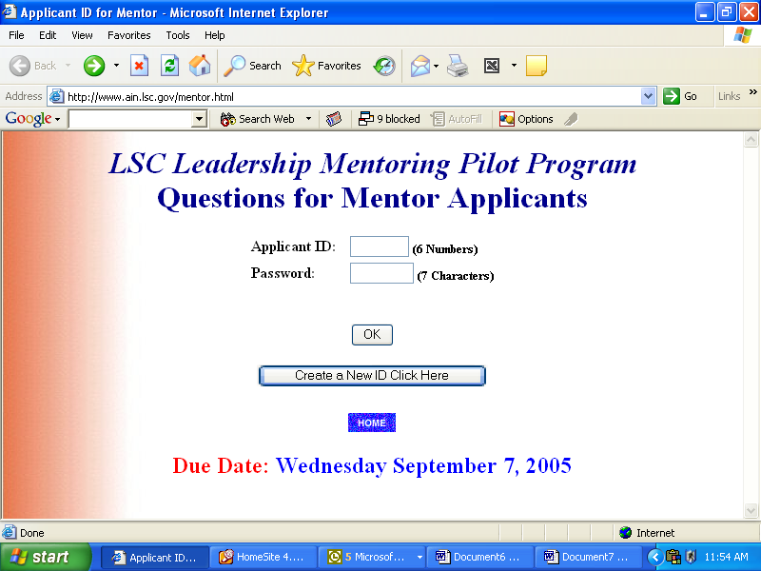
Click on the Create a New ID button. You will be presented with the following screen:
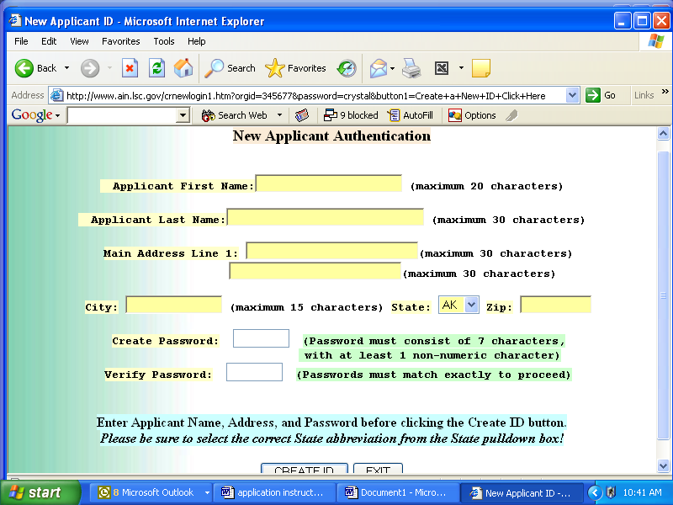
Enter your information and your password on this New Applicant Authentication screen and click Create ID. The application will generate a six (6) digit Applicant ID for you. Please record your Applicant ID next to your password.
When you have completed this process successfully, you will see the following screen with your Applicant ID. It is essential that you record your Applicant ID number and password for future access to your information. APPLICANTS WILL NEED TO ENTER THEIR ID AND PASSWORD EACH TIME THEY ACCESS THE APPLICATION. PLEASE CONTACT THE LEADERSHIP MENTORING SERVICE DESK AT LEADERSHIPMENTORING@LSC.GOV IF YOU LOSE YOUR ID OR PASSWORD.
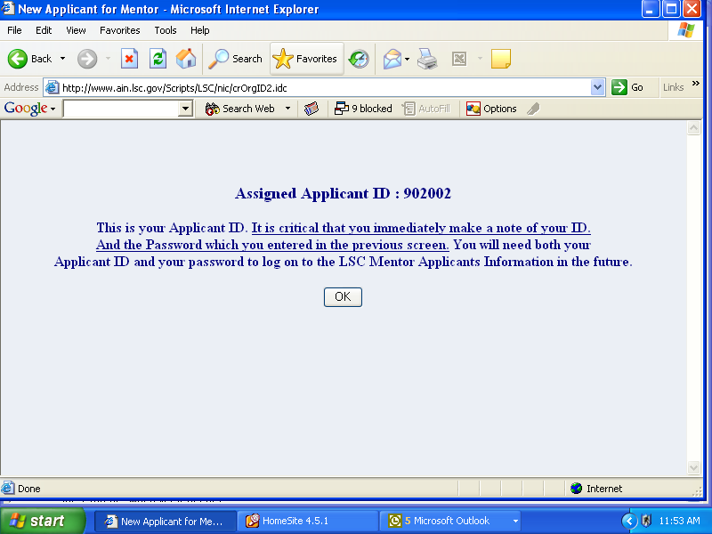
After recording your ID and password, click OK on this screen to go to the on-line Application form.
3. Fill in the on line Application form. The form has 13 blocks (grouped into three (3) sections) where you are asked to enter information. In some instances you are provided with options to make a selection. In other instances you are asked to enter text. On a few occasions you will be asked to enter dates.
Data Entry Cautions:
(a) We have established limits on the number of characters you can enter in many of the text blocks. These are clearly marked on the application. We recommend that you use the viewing facility to check to be sure you have not entered too many characters. If you have, the excess will be cut off and you will see only the number of characters permitted. In that event, you will need to edit your response to fit.
(b) Date information must be entered in the format mm/dd/yy with a limit of 10 characters. No other format will be accepted by this application.
(c) Applicants are advised to save information entered on the form frequently to avoid losing information that has been entered. The save, view and submit buttons are at the bottom of the on-line application. Once you click on the save button your work will be saved and you will be presented with a screen with a button to take you back to your form.
Additional Tips and Cautions
a) After the data entry is completed, save your work and print a copy before submitting it to LSC. You can save, edit, and make changes to the form as many times as you want. Once submitted, however, you cannot change it unless you contact LSC to “unsubmit” it. PLEASE SEND AN E-MAIL REQUEST TO LEADERSHIPMENTORING@LSC.GOV TO HAVE THE APPLICATION UNSUBMITTED.
(b) THE View OPTION WILL ALLOW YOU TO VERIFY WHETHER YOU HAVE EXCEEDED THE LIMITATION ON CHARACTER IN THE NARRATIVE FIELDS. If you have EXCEEDED THE CHARACTER LIMITATION, the excess will be cut off and you will see only the number of characters permitted in the field. In that event, you will need to edit that response to fit.
(c) Remember that you cannot make any entries while using View – you must GO TO FORM, before making any changes.
(d) If you have been employed at more than two Legal Services Programs and, consequently, have more than one entry possible under A3, just enter the most recent previous Legal Services Program – the others will be reflected in your resume.
4. Assemble your supporting information. All applicants are asked to provide a resume, approval for candidate participation from your program’s executive director (an executive director will submit approval from the program’s board chair), two letters of recommendation, and three personal references. We require this information to be combined into a single PDF file for upload through the application.

FILE UPLOAD PROCEDURES
All information transmitted to LSC through the file upload process must be included in a single PDF file. This includes the resume, approval, letters of recommendation and personal references. Please ensure that all necessary information is contained in the file (which should be seven items in all) before starting the upload process. Applicants are responsible for ensuring that the seven (7) documents comprising the supporting information package are in the stipulated sequence.
Be sure to print a copy for your records. Once it is uploaded, you will not be able to check or change it.
5. Upload your supporting information. Scroll to the link on the on-line application form labeled Click here to Upload PDF File. Click on the link. You will be presented with the following screen:
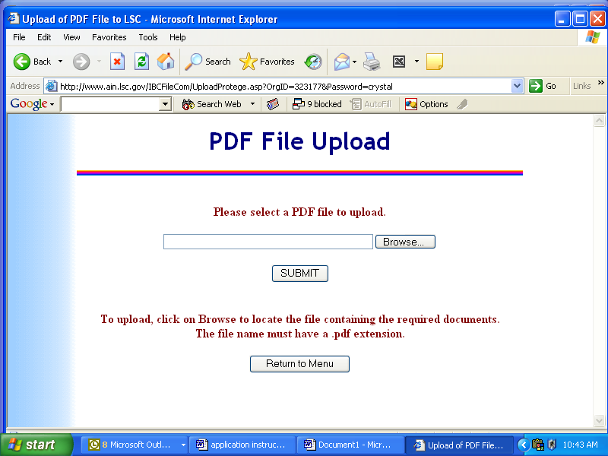
Click on the Browse button to locate the drive, directory and file where you have your PDF file. Select your PDF file. Click Open. This will place a copy of your PDF file in the upload facility for upload to LSC. Click the SUBMIT button to transmit the file to LSC. Once the file is uploaded, you will not be able to change it unless you contact LSC to “unsubmit” it.
6. Optional Information. We are requesting information on gender, race/ethnicity, age, national origin, primary language and disability. However, submission of this information is not required. You may complete some or all of the optional inquiries. Data collected will be used only as consistent with applicable law.
7. Submitting your application. Once you are certain that your application is complete, print out a copy and then click the Submit button at the end of the application. Remember that once you submit, you cannot make any changes or corrections without contacting LSC and getting LSC to “unsubmit” your application.
8. Questions. Any questions or requests about the LSC Leadership Mentoring Pilot Program or Application process should be directed to the Service Desk by sending an email message to LeadershipMentoring@lsc.gov.

