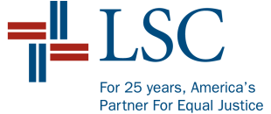
Legal Services Corporation
America’s Partner For Equal Justice
BOARD OF DIRECTORS

Resolution

Temporary Operating Budget and
Special Circumstance Operating Authority
For Fiscal Year 2016

WHEREAS, the Board of Directors (“Board”) of the Legal Services Corporation (“LSC”) has reviewed information regarding the status of the Fiscal Year (FY) 2016 appropriation and anticipated funding through a continuing resolution (CR) for LSC, and the U.S Court of Veterans Appeals grant; and

WHEREAS, the projected funds available for the Temporary Operating Budget (TOB) including projected FY 2015 carryover are as follows:

- Continuing Resolution funding of $375,000,000;

- U.S. Court of Veterans Appeals funding of $2,500,000;

- Carryover in the amount of $12,513,070, which is comprised of:

- Basic Field Programs carryover of $1,212,552;
- U.S. Court of Veterans Appeals of $2,500;
- Grants from Other Funds of $2,073193;
- Technology Initiative Grant funds of $147,739;
- Hurricane Sandy Disaster Relief Funds of $75,959
- Herbert S. Garten Loan Repayment Assistance Program of $1,463,627;
- Management and Grants Oversight Operations (“MGO”) of $2,480,225;
- MGO Contingency Funds of $4,357,275: and
- Office of Inspector General of $700,000; and

WHEREAS, Management and the Inspector General recommend that a TOB be adopted reflecting the funds available;
NOW, THEREFORE, BE IT RESOLVED that the Board hereby adopts a TOB for FY 2016 totaling $390,013,070 of which $357,161,943 is for the Delivery of Legal Assistance; $2,463,627 is for the Herbert S. Garten Loan Repayment Assistance Program; $20,980,225 is for Management Grants Oversight (“MGO”); $4,357,275 is for MGO Contingency Funds; and $5,050,000 is for the Office of Inspector General, as reflected in the attached documents; and
BE IT FURTHER RESOLVED that the Board hereby authorizes Management, in consultation with the Chairman of the Board and Chairman of the Finance Committee, to increase or decrease the annual grants awards, as necessary, in response to the FY 2016 appropriation.

Adopted by the Board of Directors
On October 6, 2015
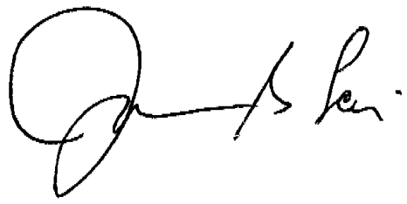

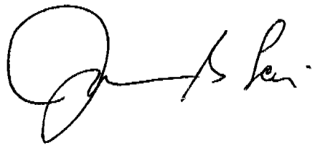
____________________________
John G. Levi
Chairman

Attest:

____________________________
Ronald S. Flagg
Vice President for Legal Affairs,
General Counsel, and
Corporate Secretary

